Online Complaint Registration and Management System
Phase 2: Requirement Analysis
SmartBridge Internship Project Submission
Team: Online Complaint Registration and Management System

2.1 Customer Journey Map
Stage | User Action | Touchpoint | Pain Point Addressed
Awareness | Discovers the complaint portal | Landing page (Home) | No prior visibility into how to raise an issue
Registration | Creates an account | Register page | No account/record tied to past complaints
Complaint Submission | Fills complaint form (title, category, location, priority) | Add Complaint page | Complaints previously scattered across calls/paper
Tracking | Views status on dashboard | Dashboard / Complaint Detail page | No visibility into progress previously
Resolution | Receives status change to Resolved | Notifications, Complaint Detail page | Long, silent wait times with no closure

2.2 Solution Requirements

2.2.1 Functional Requirements
ID | Requirement | Description
FR-1 | User Registration & Login | Users can create an account and log in securely using email and password (JWT-based authentication).
FR-2 | Role-Based Access | System supports three roles — User, Agent, Admin — each with distinct permissions.
FR-3 | Complaint Registration | Users can submit a complaint with title, description, category, location, and priority.
FR-4 | Complaint Tracking | Users can view the real-time status of their submitted complaints.
FR-5 | Complaint Assignment | Admins can assign complaints to available agents.
FR-6 | Status Management | Agents/Admins can update complaint status (Pending → Assigned → In Progress → Resolved → Closed).
FR-7 | Notifications | Users receive notifications when their complaint status changes or an agent is assigned.
FR-8 | Search & Filter | Users/Admins can search and filter complaints by status, category, or keyword.
FR-9 | Admin Analytics Dashboard | Admins can view aggregate statistics: total, pending, resolved complaints, and category/status breakdowns.
FR-10 | User Management | Admins can view all users, change roles, and remove accounts.

2.2.2 Non-Functional Requirements
ID | Requirement | Description
NFR-1 | Security | Passwords hashed with bcrypt; JWT tokens for stateless authentication; role-based authorization on all protected routes.
NFR-2 | Usability | Responsive UI (Tailwind CSS) accessible on desktop and mobile browsers.
NFR-3 | Performance | API responses under 500ms for standard CRUD operations under normal load.
NFR-4 | Scalability | MongoDB Atlas cloud database supports horizontal scaling as complaint volume grows.
NFR-5 | Availability | Hosted on Render with backend/frontend deployed as independent services for independent scaling and uptime.
NFR-6 | Maintainability | Modular MVC-style backend (routes/controllers/models) and component-based React frontend.

2.3 Data Flow Diagrams

2.3.1 DFD Level 0 (Context Diagram)
The context diagram shows the system as a single process interacting with three external entities — User, Agent, and Admin — and the underlying database.
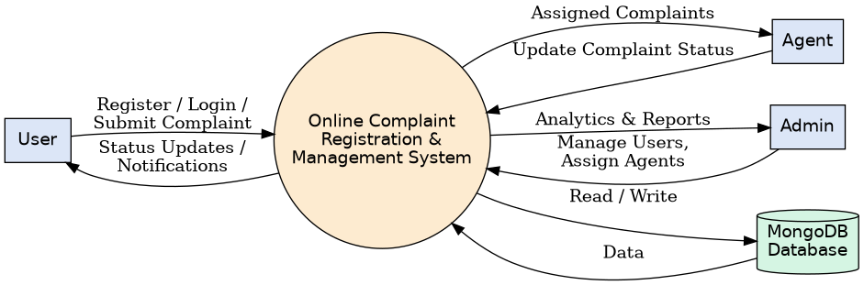
Figure 2.1 — DFD Level 0: Context Diagram

2.3.2 DFD Level 1
The Level 1 diagram decomposes the system into its core processes: Register/Login, Submit Complaint, Track Complaint, Assign & Update Status, and Notify User — along with the data stores they interact with.
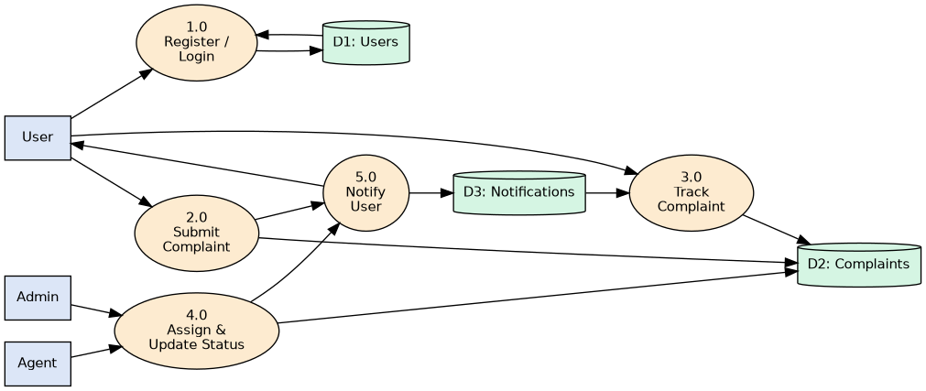
Figure 2.2 — DFD Level 1: Process Decomposition

2.4 Technology Stack
Layer | Technology
Frontend | React.js (Vite), Tailwind CSS, React Router DOM, Axios
Backend | Node.js, Express.js
Database | MongoDB Atlas (Mongoose ODM)
Authentication | JSON Web Tokens (JWT), bcryptjs for password hashing
Deployment | Render (Web Service for backend, Static Site for frontend)
Version Control | Git & GitHub

